# FINALE

In this lab, we review the things during the course and do the Cisco lab task 16.4.7 in essential parts (and a little bit more).

## Target

The objectives of the mission are to:

* Create a switched LAN
* Implement its device management with secure remote access
* Implements a dhcp service in the network to automate ip settings
* Connect the network to the Internet

# Task

To complete the task , you need in the lab

* One workstation
* One switch (a switch is not necessary, but it is also worth considering configuring it)
* One router

1. *N.B. If you're slow to do that, you can save time by just configuring the router and leaving switch-related things at the end (if time is enough)!*

Configuring lab mode C3-05 network devices is done through the console server. There is a separate instruction on its use: <https://tuni-my.sharepoint.com/:w:/g/personal/ville_haapakangas_tuni_fi/ESmlbC2l9cNFoFkwwXpXWyQBCbCZDMXvc_kYn69d4IqRtg?e=C177k0&isSPOFile=1>

## 1 Implementation of a local area network

1. Implement the local area network according to the settings in the image and table below with the lab's devices.  The workstation is a PC-A WIn7 virtual machine.

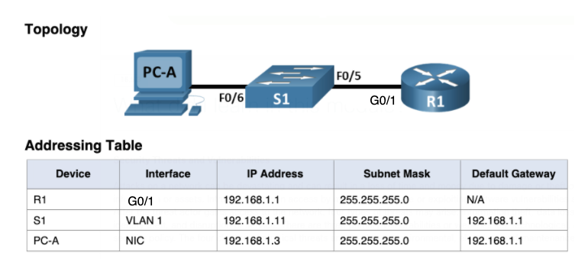

1. TEST: pinging that there is a working ip connection between all devices.

## 2 Secure management connections

1. To make a Cisco lab 16.4.7, follow these steps:
   1. Part 2: all items, i.e. Step 1-6, use your own first name (without umlauts) as the domain name, and the .test suffix, e.g.: ville.test
   2. Part 3: Step 2-3
   3. Part 4: all items i.e. Step 1-2
2. TEST: the functionality of the remote management connection to the router with ssh from PC-A using the putty program.

This is the step that needs to be reached to get lab performance. If you do not want to continue until the end, ask the teacher to review your work and go to the end instructions at the end of the document.

## 3 Automatic IP settings

Create a dhcp service on the router that automatically distributes ip settings to workstations on the network and test this by changing the PC-A settings on the workstation to automatic:

1. Copy the following commands into router configuration mode (Router(config)#). See if there are any error messages when copying. N.B! Change the "first name" to your own name!

!dhcp service

Service DHCP

.dhcp service settings

ip dhcp pool lan

network 192.168.1.0 255.255.255.0

domain-name firstname.test

default-router 192.168.1.1

DNS-Server 172.16.1.201

Exit

.' delete some of the addresses in the tree list

ip dhcp excluded-address 192.168.1.0 192.168.1.127

!

1. TEST: change the ip settings of the workstation PC-A to automatic. Does the PC get its ip settings from the server? Tip: remember the commands ipconfig /release and ipconfig /renew.

## 4 Connecting the network to Internet

The WPK network now acts as the provider of the Internet connection. Connect the network to the WPK network both physically and logically and test the functionality of the network connections to the Internet!

1. Connect the router from socket G0/0 to the WPK-marked switch in the same rack cabinet according to the following topology figure:

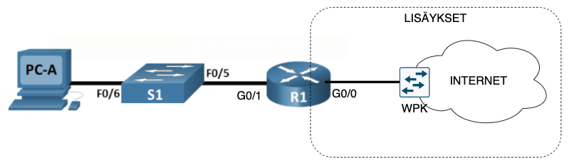

1. To configure the router's Internet connection, copy the following commands to the router configuration mode:

How to use the annex

Interface GIGA0/0

ip add dhcp

no shutdown

Exit

Default static route

IP Route 0.0.0.0 0.0.0.0 172.25.17.1

!

1. TEST:
   1. Check with the router that it receives automatic ip settings from the provider, command show ip int brief
   2. Check that the router's routing table has a default (Gateway of last resort), command: show ip route
   3. Ping 172.2 5.17.1, 172.18.1.1 and 8.8.8.8 from the router
   4. You can also test the previous pings from the workstation PC-A. Does it work? Should it?

1. Configure address translation so that workstations can also access the Internet. Copy the configurations to router configuration mode:

! Annexes

interface giga0/0

Shutdown

ip nat outside

no shutdown

Exit

Interface GIGA0/1

Shutdown

ip nat inside

no shutdown

Exit

! Address conversion settings

access-list 1 permit 192.168.1.0 0.0.0.255

ip nat inside source list 1 interface giga 0/0 overload

End

!

# FINAL TESTING

Test the operation of the network in stages from the workstation PC-A:

|  |  |  |  |
| --- | --- | --- | --- |
| SOURCE | DESTINATION | TESTING | RESULT |
| PC-A | DHCP service | ipconfig /release  ipconfig /renew  ipconfig /all |  |
| PC-A | Router G0/1 | ping |  |
| PC-A | public IP address 8.8.8.8 | ping |  |
| PC-A | DNS | nslookup |  |
| PC-A | Internet web services | browser |  |
| PC-A | Router, remote management connection | SSH |  |

# ENDING

1. Remove the connections you have made
2. To remove the settings from network devices (both!), use erase startup-config and delete vlan.dat
3. Turn off the AC adapters
4. Feedback on the workstation's network connections so that it worked with an Internet connection - test this!
5. Log out of the wpk network machine